Name- Aung Min Khant ID- 00732

Cos-209 Final project

User Manual



Home Page

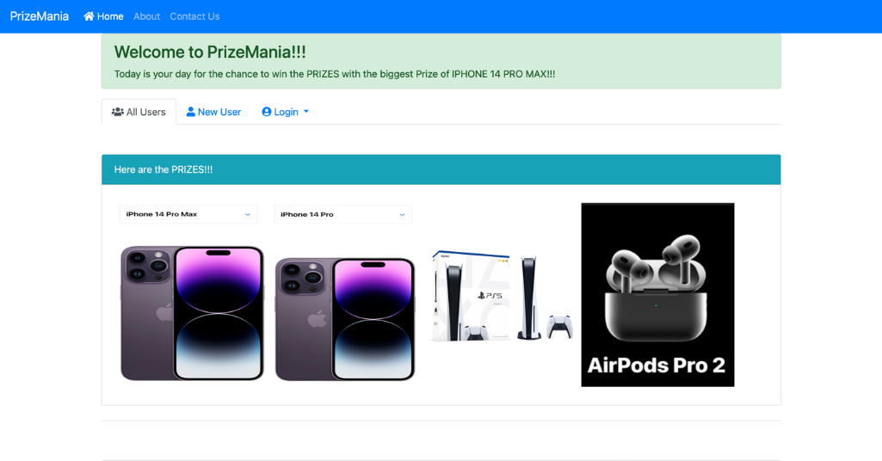

This is the home page that comprise all user, new user and login pages

This is the login for the old user and for the admin

This is the Sign-up for the new user

About Page

This is the information of the website

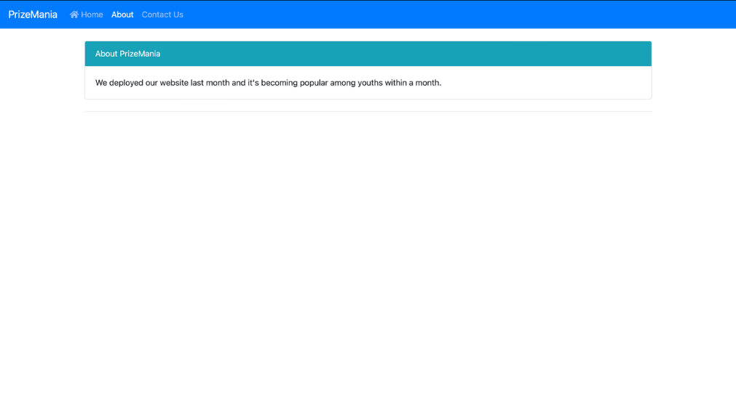

Contact Page

This is the contact number of the authorizer for more about of this site.

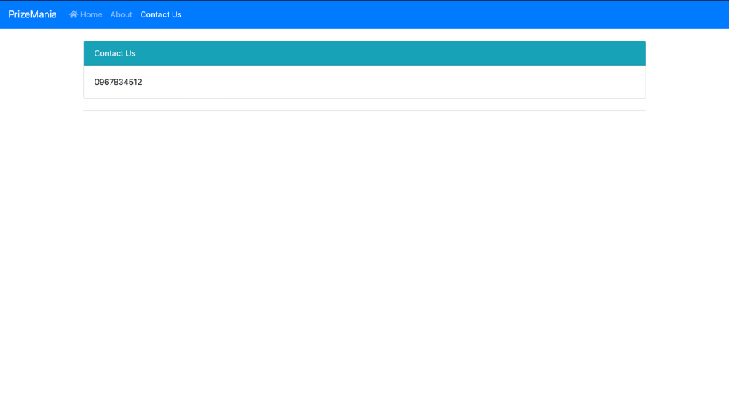

Signup Page

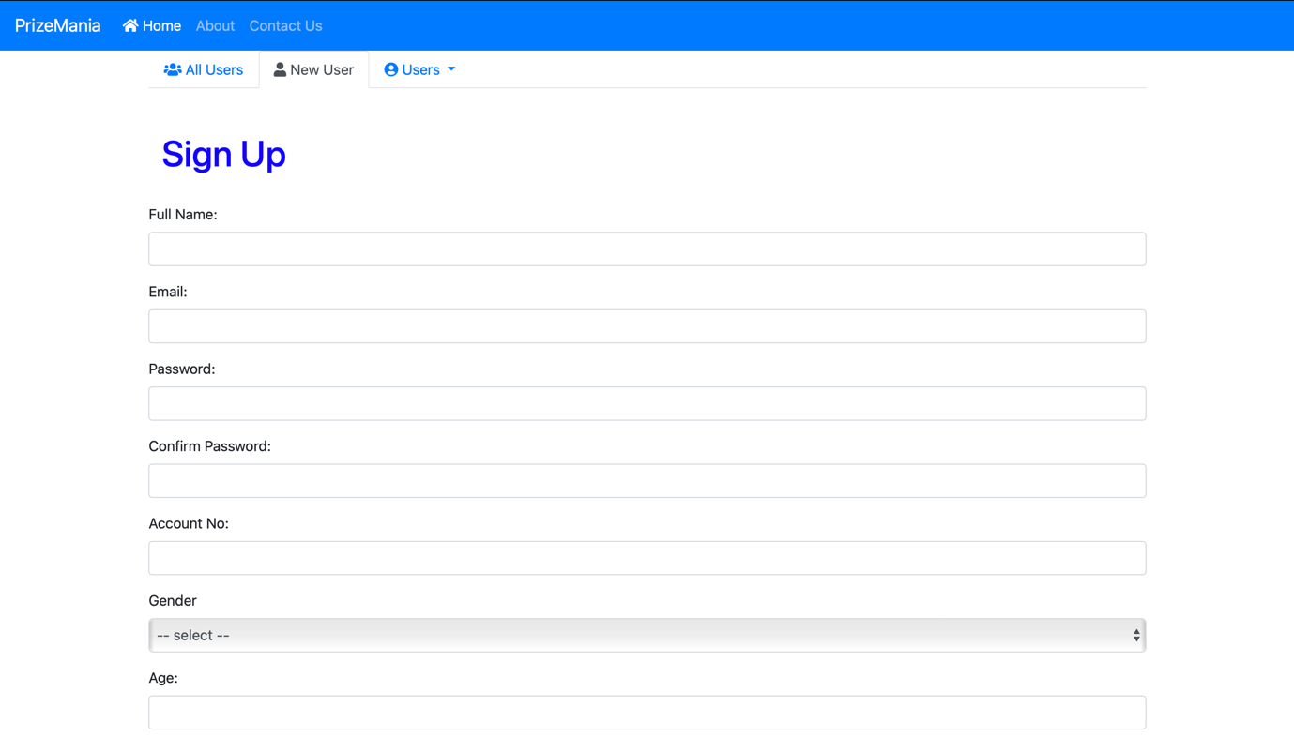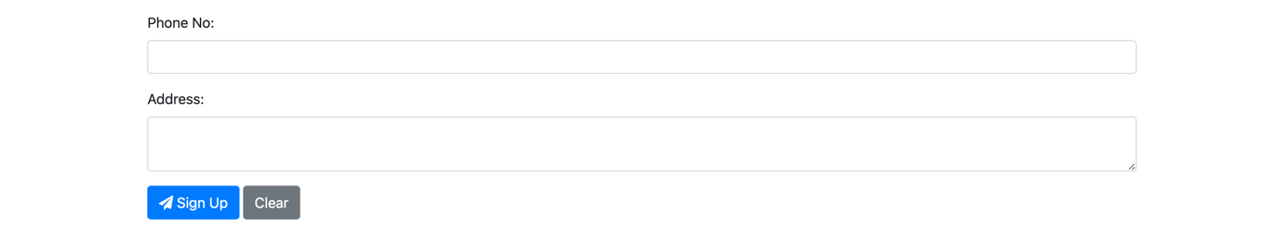

If the user is fully filled the text field and click on sign up button the data will upload in the database

This is to clear all the text field.

User Login

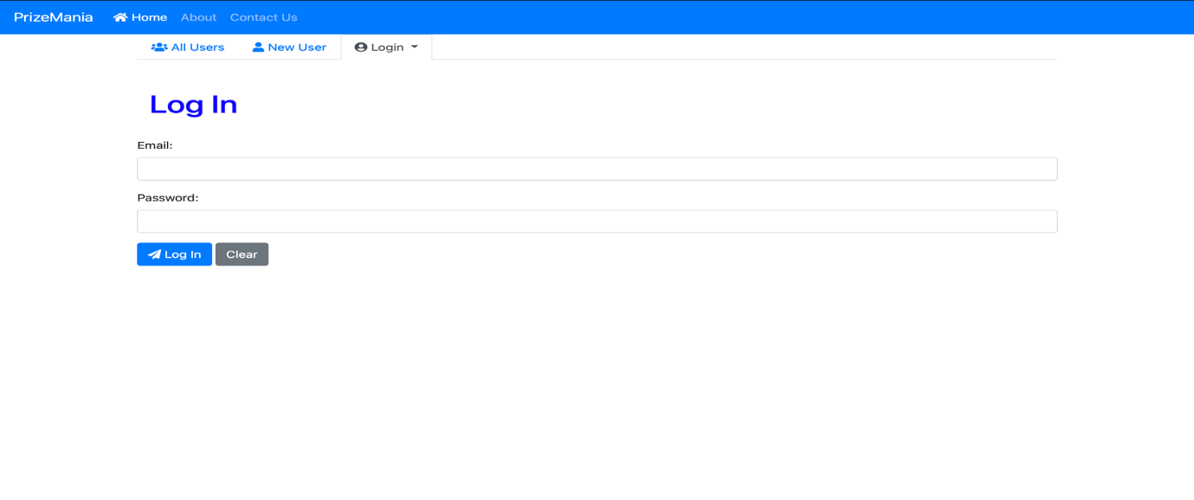

This is to clear all the text field.

If the email and password are correct the user are allowed to get into the system

Amin Login

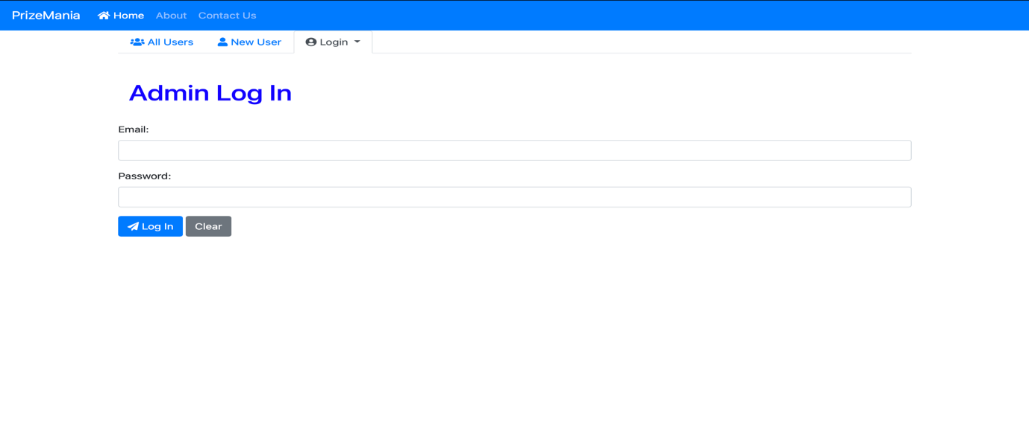

This is to clear all the text field.

If the email and password are correct the Admins are allowed to get into the system

Purchase Ticket Page

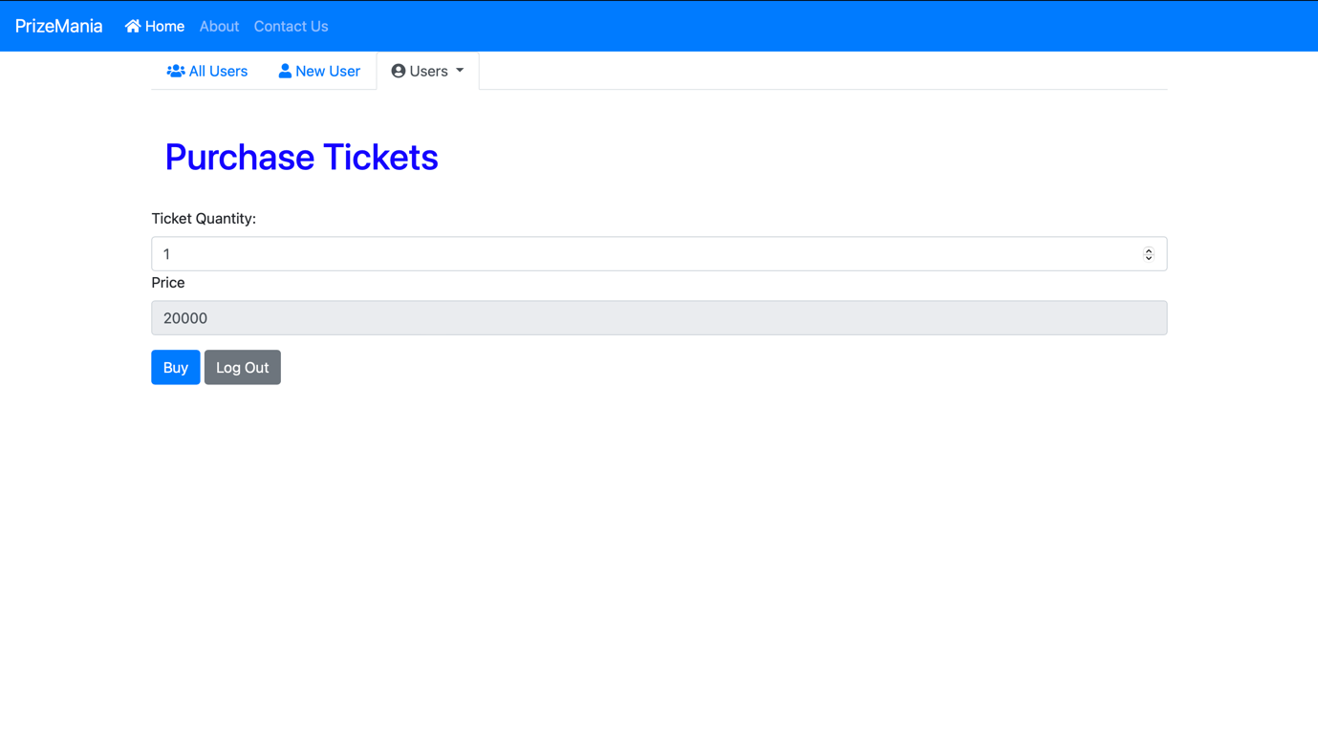

This is the log out button to logout from the system.

If users choose the quantity and click on the buy button the purchase data will upload in the database

Admin Control Page

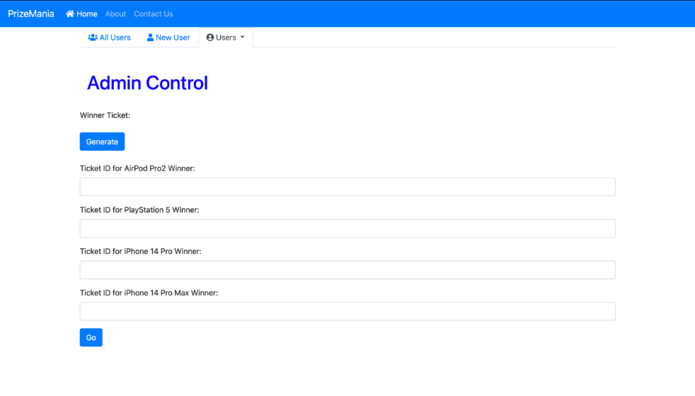

If admin click on generate button the data will appear in the Ticket id field.

If click on the go button, it will take to the winner table